**T – Times**

**Volume 30 Issue 3**

**July 2010**

**Three Rivers Model T Ford Club**

**P. O. Box 7083**

**Kennewick, WA 99336**

**“T-Times” is the publication of the Three Rivers Model T Ford Club and is published monthly solely for its members and exchange with other antique automobile groups. Editorial copy and advertisements should be sent to: Editor 218 NE A Street College Place, WA 99324 by the 25th of the month for inclusion in the next month’s issue.**

**The Three Rivers Model T Ford Club is a chapter of the Model T Ford club of America. Membership is recommended and encouraged. Make membership requests to: MTFCA P.O. Box 126 Centerville, IN 47330**

**2010 Officers**

Club President 2010            Marlene Coder

Vice President                      Dean Stokes

Secretary                              Wanda Stokes [dwstokes1@embarqmail.com](mailto:dwstokes1@embarqmail.com)

Treasurer                               Mike Porter

Newsletter Editor Dale Peterson [dpeters0258@gmail.com](mailto:dpeters0258@gmail.com)

**Board Members**

1 Year  --  Dale Peterson

2 Year  --  Marlene Coder

3 Year  --  Russ Armstrong

**The Three Rivers Model T Ford Club is dedicated to the restoration and enjoyment of the Model T Ford. Ownership is recommended but not a requirement of membership. Annual dues are $20. Monthly meetings are held the third Thursday of the month at the Reata Springs Baptist Church, 2830 Leopold Lane, Richland, WA at 7:00 PM.**

**CALLENDAR OF EVENTS**

* July 3 Breakfast at Stan Fast farm
* July 15  Annual Picnic and monthly meeting at Chiawana Park
* July 22 Tea in Sunnyside
* Aug 1-6 [MTFCA Western National Tour Whitefish, Montana.](http://www.montanamajesticmountainttour.com/)
* Sept 19-24 San Juan Islands Tour by the Seat of your Pants Tour.  Tour Chair Dale Peterson.  Details to come, watch the website for details.
* Dec 12      Christmas Party at Canyon Springs Retirement Center

**Special Dates**

**July Birthdays are:**

July 1 Lou Ottem

July 10 Paul Dionne

July 28 Betty Patterson

**No July Anniversaries**

**Monthly Meeting Minutes**

**Three River's Model T Club**

**June 2010**

  President Marlene, opened tonight's meeting with the Pledge of Allegiance.  We had a good turn-out of members.

Wanda read the minutes from May. There were two corrections:  The Fourth of July event at Howard Amon Park is not a parade, but a celebration of the 4th.  The first 200 people attending get free hotdogs.  The second correction is that the car show is at Canyon lakes June 19th.  The truck show is at Sacagawea Park June 12 and 13.

 Treasurer Mike gave his report.  We have $1411.06 plus Paul and Doris Burma dues making our balance $1431.06.  Mike read a letter praising the Three River's Model T club web page from Lucille Knutson who is looking forward to more issues.  Thank you Lucille!

 Wanda read Ken TerMaaten's obituary, a beloved member who recently passed away due to heart attack.  Marlene asked for a vote to send $50 to Sunnyside Christian Schools as a memorial to Ken at his request.  Mike wrote a check and Wanda will deliver to Sunnyside Christian Schools.

**Old Business**

 Our web page master, Dale Peterson volunteered to send copies of the newsletter that is on-line to those folks who do not have a computer.  Thank you, Dale.

The Soap Lake Tour was a huge success, Thank you Dale and Sharon.

 Mike said that **Stan Fast** would like to host us to **breakfast** again this year.  Mike will call Stan for more information of date and time.  After some discussion, it was decided that **Saturday, July 3rd (Saturday)** we will **meet at I-Hop in Pasco at 8:30** to be at the Fasts' at 9:30 AM.  The Fasts asked that no donations or help is needed.

Wanda reported that the **Tea in Sunnyside** was cancelled and rescheduled for **July 22 (Thursday**).  Wanda will call The Elms Bread and Breakfast to reschedule the date for July 22nd at 2:00 PM.  Please be at the **Stokes in Sunnyside July 22nd at 9:00** **for breakfast** and then we will tour to the nurseries and then have **high tea at 2:00 PM**.  If you would like to dress vintage, it would be wonderful.  This has been confirmed with Cheryl at the B&B in Sunnyside.  Please call **Wanda (509) 837**-**7443** or tell her at the Picnic in the Park on July 15th so she can give Cheryl the number of folks coming.  Thank you.

Our **Picnic in the Park** will be **July 15th (Thursday at Chiawana Park** (from West Court Street, go South on Road 88).  The park runs along the Columbia River.  We are at the far West end for the picnic.  The **picnic will begin at 6:00 PM**.  Dean asked for the club to provide the chicken (Mike & Linda will pick up the chicken) everyone else is asked to bring table service, something to drink, a salad or desert or both.

**August 1-6 is the National Model T Tour to Whitefish, Montana**.  Several members are going.

**September 19th - 24th is the San Juan Islands Tour** hosted by Dale and Sharon Peterson.  More information coming.

**New Business**

Fred Fraser reported that the Model A Club members in Walla Walla have been pulled over by highway patrol for not having license plates.  Fred will print out a copy of the actual law that ***does*** permit collector cars to travel public highways with collector or original licenses.  Thank you, Fred.

Those folks having birthdays in July are:  July 1, Lou Ottem, July 10, Paul Dionne & July 28, Betty Patterson

Happy Birthday to each of you.

Anniversaries are:  (no-one)

With nothing more to come before the members, the meeting was adjourned.

Respectively Submitted,

Wanda Stokes, Secretary

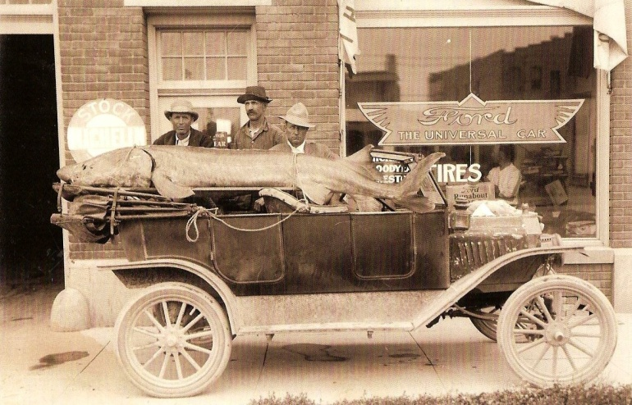

Picture postcard from Twin Falls, ID of photo by Clarence Bisbee, prolific photographer in the early part of the 1900’s when the area was being settled and developed for agriculture. Sturgeon was said to weigh in at over 1000 pounds and was caught using a rope and a Model-T!

The photo was taken in front of Union Motors in Twin Falls

**T Memories**

Submitted by

Mary F

A 1919 Model-T Ford that we saw recently at an old car show where we were with Fred and Mary, brought back memories of the 1918 Model-T that my folks had when I was a little kid. Our car had three little rectangular windows in the back and started by means of cranking. My Dad drove this car to Meridian High School where he taught. When I was in the first grade, I rode as far as Locust Grove School, about one and a half miles with him and several high school students from the neighborhood. There were no school buses in those days.

The gas tank for the Model-T was under the front seat. The gas fed into the motor better if the car was fixed so that the front seat was higher than the motor. When climbing a rather steep hill, it worked a lot better for the Model-T to back up the hill. Our house was at the foot of quite a hill and quite a few times we would see a Ford backing up the hill, especially if it was muddy and slick.

In the summer of 1924 my family, along with two other high school teachers and their families made a trip “back east,” we called it then, although it was really to the Middle West; Kansas Missouri, and Iowa. The other families had various destinations, one to Greely Colorado where they were going to summer school, and I don’t remember how long the other car stayed with us, but we ended up visiting lots of aunts, uncles in various places and Grandpa and Grandma Goodell who lived at Hale, Missouri.

The roads all along the way were very rough and dusty. Lee, who was four, and I would lie down in the back seat and say, “Wake us up when we get to the next town.” There were no seat belts in those days and it would be easy for a rambunctious kid to fall out of the car. We were strictly forbidden to stand up in either the seat or on the floor between the seats.

Every night we camped, cooked over a campfire, and slept in a tent that fit over the top of the car. Mother and Dad slept in the tent and Lee and I had a bed that someway fit over the front and back seats of the car. I don’t know how many miles we covered in a day, but I remember Dad saying that sometimes we got up to twenty-five miles an hour on good roads. I think we traveled on what later became Highway 30, but then it was call the Samson Trail. Every so often there would be a dab of orange paint on a rock or a post and that told us we were on the rght road. As I remember, there were lots of detours. Sometimes we would bounce down and cross a ittle stream without a bridge. Lee said he knew what detour ment. It ment bad road!

As I remember, we had no motor trouble along the way. One time in Kansas we were trying to go up a steep muddy hill with no luck. Finally Dad turned the car around and Mother got out with some kind of block of wood and Dad would back up the hill a few feet and mother would put the block under one of the front wheels so the car would not loose the few feet it had gained. We finally got up the hill. Mother didn’t like to take trips in the car. I wonder why. In spite of rough roads and all, I remember Dad bragging to various relatives that we still had Idaho air in all the tires.

(Jim’s turn) My folks had a 1912 Ford-T which I remember but not very well since I was born in ’17. Of course it had to be cranked and I think my Mother never drove it, or at least not very much. It seems like the head lights were different from the later models. I do remember my folks telling about the time my Dad took another man and my sister Mildred who must have been about nine years old or less, out to the grain field to see how it was doing. My dad left Mildred in the car and he and the other man went off some distance into the grain field. They looked around to see that Mildred had cranked the car and was headed along the edge of the field. The two guys ran and hollered like mad and my sister either stopped the car or they caught up with her. My Dad seemed to be a Ford man. While at school during recess I saw him bring home a new 1923 Model-T. Part of the time we also had a couple other makes of cars, but we were never without a Ford. The ’23 Ford was traded in on a ’29 Model-A and later on my folks had a ’36 V-8 which he traded for a 1951 Ford sedan.

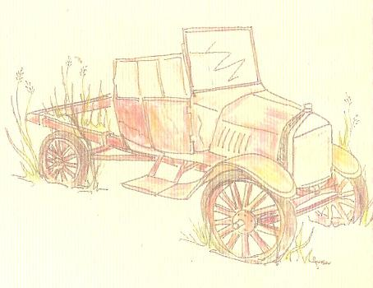

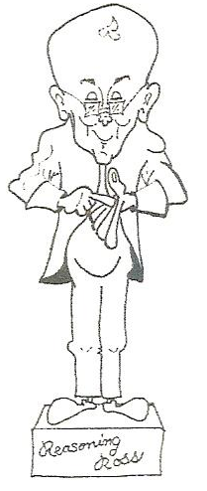

**Me**

**And**

**The**

**Model-T**

**Bill Sheller**

Gasoline; You know, the stuff that makes the Model T Ford go down the road and put that wonderful warm and fuzzy feeling in your soul. Just a year or so ago, the mere price of that stuff usually produced some sort of ill feeling’s against the big oil companies. Just to think you could actully put prit-n-ear forty dollars worth of the precious fluid in a 10 gallon Model T gas tank… WELL! It has been documented that Henry himself had worried about running out of oil as far back as the teens of last century, when the Model T Ford was a “fledgling” concern. However, I’m pretty sure he never could have imagined it costing as much as it did. Well, after the banking bail out this past late summer, the oil executives looked like cherubs compared to the bankers! History will also show that ole Henry wasn’t much for bankers either. As I get older, it seems as quickly as things seem to change, the more they really just repeat themselves. Seems I’ve seen this all before, history just called it something else. Okay, so what’s your point , Bill?

Gasoline: In keeping with my above ramblings we’ve been putting “additives” in gasoline almost from the time mankind invented the explosive. During the Model T’s day, folks put camphor in gasoline to reduce soot. Some folks used benzol, which was supposed to reduce carbon knock. It’s been documented a Model T would run on kerosine once the engine was warmed up to operating temperature. As compression ratios increased we put lead into gasoline to help prevent pre-ignition. All of these “schemes” have earned their place in motoring history. However, there is one more that when it takes its place in motoring history, had darn well better start out with “Once upon a time!” Yes, I’m speaking of putting corn syrup in gasoline. The politicians call it ethanol, and it’s really a great boost to the farmers I recon, but… You know it’s presence (10%) by LAW in Oregon is really not noticable in our modern vehicles, but in cars like Henry, it has some serious side effects! (Sorry, Henry, I really didn’t mean to imply there were ANY cars Like you.) As long as you’re running the stuff through regularly, other than a noticeable power loss on inclines, you can get away with it. It’s when it sits in the fuel system for even a relatively short period of time. Say like 60 to 90 days. Even if you use a fuel stabilizer, which in my opinion only stabilizes the gasoline and does NOTHNG for the corn syrup. So the corn syrup is free to turn to black gooey tar. Well,… even Henry won’t burn tar!

There is some hope, which may require a little on your part. You can still purchase “un-sugared” fuel at certain stations for use in small engines like lawn mowers, chain saws, etc. They won’t pump it into your Model T fuel tank, but when you go to put the old T up for a spell, go get some of this stuff, put some stabilizer in it, drain the corn searching syrup out… well, you get the idea! Henry built a darn good car… Yes He did!

|  |  |  |  |  |  |  |  |  |  |  |  |  |  |  |  |
| --- | --- | --- | --- | --- | --- | --- | --- | --- | --- | --- | --- | --- | --- | --- | --- |
| **Kenneth Wayne Ter Maaten**  (November 17, 1943 - June 4, 2010)   |  |  |  |  |  |  |  |  |  |  |  |  |  |  |  | | --- | --- | --- | --- | --- | --- | --- | --- | --- | --- | --- | --- | --- | --- | --- | | http://www.webfh.com/images/spacer.gif | |  |  |  |  | | --- | --- | --- | --- | | http://www.webfh.com/images/frames/PaintedBlue/11.gif | |  | | --- | | http://www.webfh.com/images/frames/PaintedBlue/41.gif | | http://www.webfh.com/images/frames/PaintedBlue/71.gif | | |  | | --- | | http://www.webfh.com/images/frames/PaintedBlue/14.gif | | Kenneth Wayne Ter Maaten | |  | | --- | | http://www.webfh.com/images/frames/PaintedBlue/74.gif | | | http://www.webfh.com/images/frames/PaintedBlue/17.gif | |  | | --- | | http://www.webfh.com/images/frames/PaintedBlue/47.gif | | http://www.webfh.com/images/frames/PaintedBlue/77.gif | |   Kenneth Wayne Ter Maaten went to be with His Lord on June 4, 2010. He was born on November 17, 1943 in Artesia, California to Case and Cleone Ter Maaten. Ken attended Ontario Christian School and graduated from Corona High School and Chaffey College in southern California. On April 9, 1965, he married Bernice Koops and they made their home in Mira Loma, California, where he began his dairy farming business and they began raising their family. In 1970, Ken and Bernice, along with their two young children, decided to begin a new adventure and moved their dairy farm to Sunnyside, Washington, where their family continued to grow with the addition of two more children. In 1974, they moved to Grandview, Washington where they built their new dairy and continued their operation there for 30 years. In 2007, they sold the dairy and moved to their hay farm in Prosser, where they were currently living. The most important things in Ken’s life were his faith in God and spending time with his family. He was a lifelong member of the Christian Reformed Church and supported Christian education. Ken loved planning social events and trips with his family and friends. He had many hobbies including: motorcycling, boating, water skiing, fishing with his grandchildren, traveling, antique collecting, toy train collecting, and restoring old tractors and classic cars. He lived life to the fullest. He is survived by his loving wife of 45 years, Bernice, and four children: Darla (Brian) Rogers of Sunnyside, Julie (Fred) Broersma of Sunnyside, Casey (fiance Tara) Ter Maaten of Spokane, and Karen (Brandon) Walker of Prosser, and 12 grandchildren whom he loved dearly. He is also survived by his sisters, Anna Marie (Jake) Van Vliet of Ripon, CA, Jeanie (Arend) Van Vliet of Oakdale, CA, sister-in-law Debbie (Rick) Mouw of Lynden, WA, and numerous nieces and nephews. Ken was preceded in death by his parents, Case and Cleone Ter Maaten, and two brothers, Roger Ter Maaten and Steve Ter Maaten. Viewing and visitation will be held Thursday, June 10, 2010 from 12:00 P.M. until 8:00 P.M. at the Smith Funeral Home, Sunnyside, WA. Graveside Services will be held Friday, June 11, 2010 at 9:30 A.M. at the East Prosser Cemetery, Prosser, WA. Memorial Services will be held Friday, June 11, 2010 at 11:00 A.M. at the Sunnyside Christian Reformed Church, Sunnyside, WA. Those wishing to honor Ken’s memory may contribute to the Sunnyside Christian School. Those wishing to share their memories or sign Ken’s online memorial book may do so at www.funeralhomesmith.com |

For Sale

Car for Sale: 1915 Model T Touring. All black very reliable tourer that is ready to go this season with std geared large drum Ruxtell and natural finished wood de-mountable wheels & tires. Non-demountable natural finished year correct wheels & whitewall tires available in place of de-mountables. Spare tire(s), side curtains, luggage rack, hand Klaxon, Stewart speedo, std ignition, Holley 3-screw carb, 12v alternator and 12v battery. $15,000 obo. Randy Murray  
206-522-4196 Seattle, WA

Wooden wheels with hubs and split rims. $600.00 Yellow/black 1923 Model T Touring with Rocky Mt. Brakes, Ruxtel rear end, down draft carburetor, wind wings, excellent tires on wire wheels, luggage rack with tool box.  $11,000.00. We have pictures we can send if there is any interest. Judy and Ivan Dike  
Phone number- 541-561-7123  
Email Address: [dike97838@hotmail.com](mailto:dike97838@hotmail.com)