T-Times
Volume 30 Issue 2
June 2010

Three Rivers Model T Ford Club
P. O. Box 7083
Kennewick, WA 99336
2010 Officers
Club President 2010 Marlene Coder
Vice President Dean Stokes
Secretary Wanda Stokes dwstokes1@embarqmail.com
Treasurer Mike Porter
Newsletter Editor Dale Peterson dpeters0258@gmail.com
Board Members
1 Year -- Dale Peterson
2 Year -- Marlene Coder
3 Year -- Russ Armstrong
The Three Rivers Model T Ford Club is dedicated to the restoration and enjoyment of the Model T Ford. Ownership is recommended but not a requirement of membership. Annual dues are $20. Monthly meetings are held the third Thursday of the month at the Reata Springs Baptist Church, 2830 Leopold Lane, Richland, WA at 7:00 PM.
“T-Times” is the publication of the Three Rivers Model T Ford Club and is published monthly solely for its members and exchange with other antique automobile groups. Editorial copy and advertisements should be sent to: Editor 218 NE A Street College Place, WA 99324 by the 25th of the month for inclusion in the next month’s issue.
The Three Rivers Model T Ford Club is a chapter of the Model T Ford Club of America. Membership is recommended and encouraged. Make membership requests to: MTFCA P.O. Box 126 Centerville, IN 47330

CALLENDAR OF EVENTS

- June 17 Monthly Meeting at Reata Springs Church. Snacks by Fred and Mary Fraser
- June 19 Car Show at Canyon Springs Retirement Center, lunch provided
- July 15 Annual Picnic
- Aug 1-6, 2010 MTFCA Western National Tour Whitefish, Montana.
- Sept 19-24 San Juan Island Tour by the Seat of your Pants Tour. Tour Chair Dale Peterson. Details to come, watch the website for details.
- Dec 12 Christmas Party at Canyon Springs Retirement Center

Special Dates
June Birthdays are:

Jane Armstrong - 6/03
Richard Seewer 6/16

June Anniversaries are:

Larry & Marlene Coder 6/4
Joe & Jolene Kuhns 6/06
Larry & Hattie Huetson 6/13
Jim & Betty Patterson 6/17
Merle & Bertha Feik 6/20
Mike & Linda Porter 6/22
Jim & Sandi Elenbaas 6/29

Three River's Model T Club
May 2010 Minutes

Tonight's meeting was opened by President, Marlene Coder with a good turnout of members. The Pledge of Allegiance was said by all present.

Marlene asked Mike Porter, Treasurer, for his report. Mike reported that we have one new member Dave Ottem from Othello, WA. Also Paul & Doris Burma have renewed their membership which will be reflected on next month's report. Mike also shared the copies of newsletters from other Model T clubs. He reported that government filing report has been done and approved.

Wanda Stokes, Secretary read the minutes from April with no corrections or additions. Wanda will send "thinking of you" card to Ernie Ferguson of Boardman, Oregon.

Old Business

Marlene asked for a report on the tour to Meacham, Oregon. Mary Fraser said the road was a masterpiece to build back in the day. Wanda reported the great lunch and the weather cooperated. All who participated enjoyed the tour. Thank you Jim and Phyllis Langdon for hosting this tour.

Dale Peterson gave an update on his tour to the San Juan Islands in September. For complete information, please check out the newsletter portion on the website – threeriversmodeltfordclub.yolasite.com. Dale that said that if you are planning to attend, get your reservation in at Captain Whidbey Hotel (1-800-366-4097) soon as they require reservations now. The tour sounds like it will be terrific.

Soap Lake tour is this weekend. There are approximately 16 people who are going. Dale and Sharon will be preparing gourmet waffles for all members who attend. He gave the telephone number for the Soap Lake Inn for those who decide at the last minute if they want to go. Sounds Great.

May 1st was the Swap Meet at the Benton County Fairgrounds. It was reported that the venders were down one third, and the weather was "iffy".

June 12th & 13 is an old truck show at Sacagawea State Park for those who would like to attend. Wayne Williams sent Wanda a flyer that was passed around for those interested.

June 19th is a car show for those who want to attend at Canyon Lakes Retirement Center.

July 15th will be our Potluck in the Park. This is a yearly event for us and more info is forthcoming.

Jane Armstrong reported that there will be a Parade on July 4th in Richland.

Our Christmas Party will be Sunday, December 12, 2010 between 1:00 p.m. and 3:30 p.m. at Canyon Lakes Retirement Center in Kennewick.

New Business

Fred Fraser asked if the women wanted a tour doing "women things" without the men complaining. "YES" was the women's answer. Several suggestions were made such as a nursery tour, antique tour, tea, and teaching wives to drive. Wanda volunteered to check our VanWingerden Greenhouses to see if they would let us tour them and tea at a place in Sunnyside. More later if this pans out.

Wanda told of the Sawyer Mansion in Sawyer, Washington, tour that was this past weekend. Very interesting tour.

Marlene read the dangers of a little green garden snake. Very funny. Thank you Marlene.

With nothing more to come before the members, the meeting was adjourned. A birthday cake was brought by Jane Armstrong in celebration of May's birthday's and Russ upcoming knee replacement.

Respectively Submitted, Wanda Stokes, Secretary

Tours

Meacham Tour
On April 17 our Three Rivers Model-T Ford Club had a fun tour to Meacham. The event was planned by Jim and Phyllis Langdon, and we left from their home in the morning. They led us over miles and miles of Model-T-appropriate roads. Fred calls these dirt roads, "color-changing roads."
We also drove over the old Cabbage Hill Road. It is amazing to imagine this road through the mountains being built from 1915 to the early twenties with the equipment available then.
We had lunch and a visit at the restaurant in Meacham. Weather was clear and sunny all day, so we could enjoy the beautiful scenery we passed. Thanks to Jim and Phyllis for planning this interesting trip.
Mary Fraser
Soap Lake Tour
May 22 five Model T’s and four Model A’s met at the Pasco Wal-Mart parking lot for an overnight tour to Soap Lake led by Dale and Sharon Peterson. The drive started out Route 68 heading north through the farm land past newly mown hay. What a wonderfully fresh smell to make this a very pleasant drive. The tour leader was having trouble following his own directions as we followed back roads to the north, skirting the towns of Othello and Moses Lake. Basin City and Warden were nice sceinic and sleepy little towns to drive through on a weekend day. Having made a wrong turn, bypassing Basin City on the way north, Jim and Phyllis Landgdon didn’t get a chance to fill up their gas tank. Since they had driven from Hermiston to the starting place, they just couldn’t quite get enough miles out of their tank and ran dry near Radar Hill. Fortunately, Sharon was following in the trouble truck and the gallon of gas in the trailer got them on in to Soap Lake.
The Inn at Soap Lake was initially built in 1905 as a stable and blacksmith shop. In 1915 it was purchased by Roxie Thorson and her husband and converted into a hotel, now one of the oldest buildings in Grant County. The inn was purchased by Cory and Nancy Wold in 1993 and restored to its former glory.
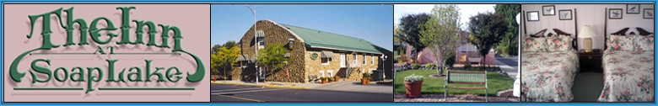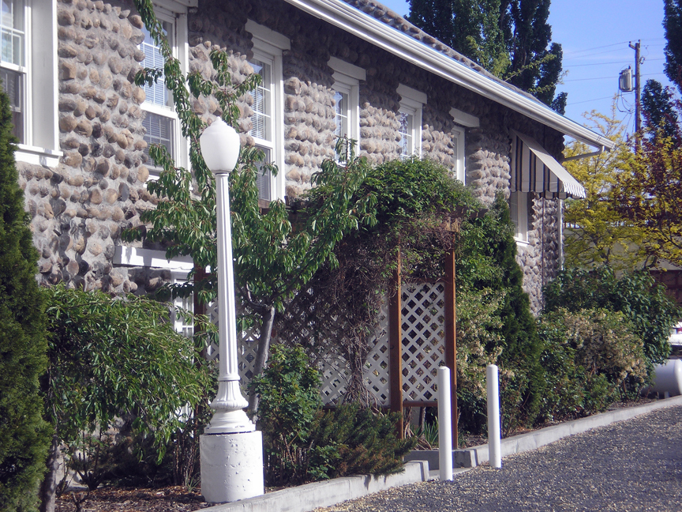
The main building is constructed of river rock walls and contains sevel quaintly decorated rooms where several of the tourists were able to enjoy the night. Green grass filled the courtyards and sidewalks lead to the shores of the lake. Most rooms had heated mineral water from the lake piped into a tub or whirlpool. Some of the tourists, therefore, were not seen once we arrived untill the following morning. The mineral water had a soap like slippery feel that I suspect may have had as much to do with the naming of the lake as the foam that once ringed the shores.
Sunday morning we were allowed to sleep in before arriving at the Peterson’s patio for a gourmet breakfast of gingerbread waffles and fruit.
Once the dishes were cleaned up by a crew of very nice ladies, it was into the cars for the trip home. Half of the cars headed strait south since they were from the Sunnyside area and that made a much shorter drive home for them. The rest decided that a different route home would be prefered so off with Dale in the lead we went. Unfortunately, he was still having trouble following directions and made a few wrong turns again. The days drive again took us through some wonderful farmland, this time on the Royal Slope and across The Potholes and Columbia National Wildlife Refuge. Oh, would I like to have had more time to stop to bird watch and just look in general!
On the first day Dale was told he was maybe driving a little fast (40-45mph). Having remembered trying to keep up with Mike and Dean in the past made it hard to slow down. However, the wind on that strait 1915 windshield kept the speed down on the way home to a much more reasonable 35mph. Soon the end of the tour was reached at Pasco with goodbye’s at Glade Road east of the airport. No major troubles on the trip, ‘cause, as Bill says, “Henry built a darn good car… Yes he did!”

Lessons Learned the Hard Way
Dale Peterson
It was 1991 when I first became the owner of my first Model T. Over they years since then I have learned a few things about this unique automobile. Some were learned, as would be recommended, from others and reading/ research. Others were learned as my father often told me, “the hard way.” One of those lessons seems to be to not take on a project like resurecting the club newsletter unless you have a sourse of filler matterial so that it doesn’t seem to be overly brief. So to make sure that you feel you are getting your value out of this newsletter, I will take it upon myself to “fill in some of the space with a column entitled, “Lessons Learned the Hard Way.” Included will be some of the lessons I have learned along with my family history involving the Model T.
Club members attending the April 2010 meeting had the priveledge of meeting my uncle, Lavar. He has restored several Model T’s and a few Model A’s over the years, around maybe a dozen. He was fortunate to have a vocation that lent itself well to restoring of old cars, farming. The reasons this is so are several. For one, once the crops are out and the machinery repaired after the years use, there is in Southern Idaho a space of time to fill with some type of hobby. For another, he has been able to rub shoulders with many old farmers. And it is the old farmers who have barns and barnyards that hold a multitude of old cars and parts.
One early memory of Uncle Lavar and his Model T’s involves parades. Hagerman, Idaho has for years had a celebration for Pioneer Day the last weekend of July. For the 1961 parade, Uncle Lavar planned to drive his 1926 roadster. Wendell, where he lives is only about 10 miles from Hagerman, so it is an easy drive over for a parade that starts at, as I remember, about noon. On the way over, he lost his fan belt. In Idaho, in late July, no one is able to drive a Model T in a parade with out a fan belt, so off we went to my Grandfather McAnulty’s home a mile from town. A piece of leather harness and a couple of rivets and the parade was saved. Lesson one, Model T’s are easy to fix with whatever you can find at hand in the barn. Also, I was hooked on a love afair with old cars.
Now back to that first Model T. In about 1962 my father brought home a 1918 Chalmers touring car. He promptly pulled the engine and took it over to Chet Rice in Wendell who assured him that he could go over it and get it in running order. The car was said to have been found in a mine in Oregon and was in mostly good condition at the time. I remember many hours with two brothers and a sister traveling on many adventures in that car parked in the farmyard.
But alas, the motor didn’t make it back from Mr. Rice by the 1980’s and Dad’s health went south before any work was done on it. Uncle Lavar purchased the car more to help Dad out and it sat a few more years in his farm yard. When Dad died in 1986, I asked Uncle Lavar about the Chalmers and he told me I could have it if I would use it to get someone else interested in old cars. The car was loaded up and hauled to our home in Twin Falls. Weather and years had not been so good to it as it now needed several ropes and some baler twine to hold it together for the 25 mile ride home.
By the end of that year, I found that solo medical practice was not easy, so we packed up and moved to Hermiston, Oregon. Now, if you are serious into old cars, you need to join an old car club. In Twin Falls, there was a general old car club, but it seemed most of the members drove newer clasic cars and either left the old slow cars behind, went on tours that were too long for slow cars, or just camplained about how slow they were. I had read a few of Uncle Lavar’s Vintage Ford magazines and was aware that there was a club in the Tri Cities area, just about 40 miles from Hermiston. A 1918 Chalmers is no Model T, but I joined the Three Rivers Model T Ford Club in 1989 since they would likely be driving their cars at my speed. Also, I remembered my family’s history with T’s and had it in the back of my mind some day to own one.
Well, three years in Hermiston and I missed being around family and home, so we went back to Twin Falls to give it another go. The Chalmers was packed up again and moved back to Idaho, now in parts and the initial motor work started.
When getting into old cars, it would probably help to have a running car to enjoy and to keep interest in the hobby up. Lesson number two, for your first old car, buy one already restored or that is easily restored. A Chalmers is not an easy restoration as there are not that many around. Even litterature and shop manuals are not easily come by, and you cannot just pick up a catalog to order replacement parts like for a Model T.
So it finaly came to me that if I was to enjoy old cars, I needed to get an already restored and afordable one, or at least an easy restoration, while I continued to work on the Chalmers. Now since Uncle Lavar seemed to have a lot of conections and knew a lot of the right people, he was told of my desire for a Model T. This pleased him well. But not just any Model T would do, I wanted a 1915 Touring, since it would work for Horseless Carriage Club activities, carry the whole family, and I really liked those older cars the best.
But, I have gotten distracted again. Since this is getting on the long side, the story of my first Model T is going to have to wait until next month.

For Sale
Fork mounted electric headlight (1) for early 1915. Dale Peterson 509 529-0258.

